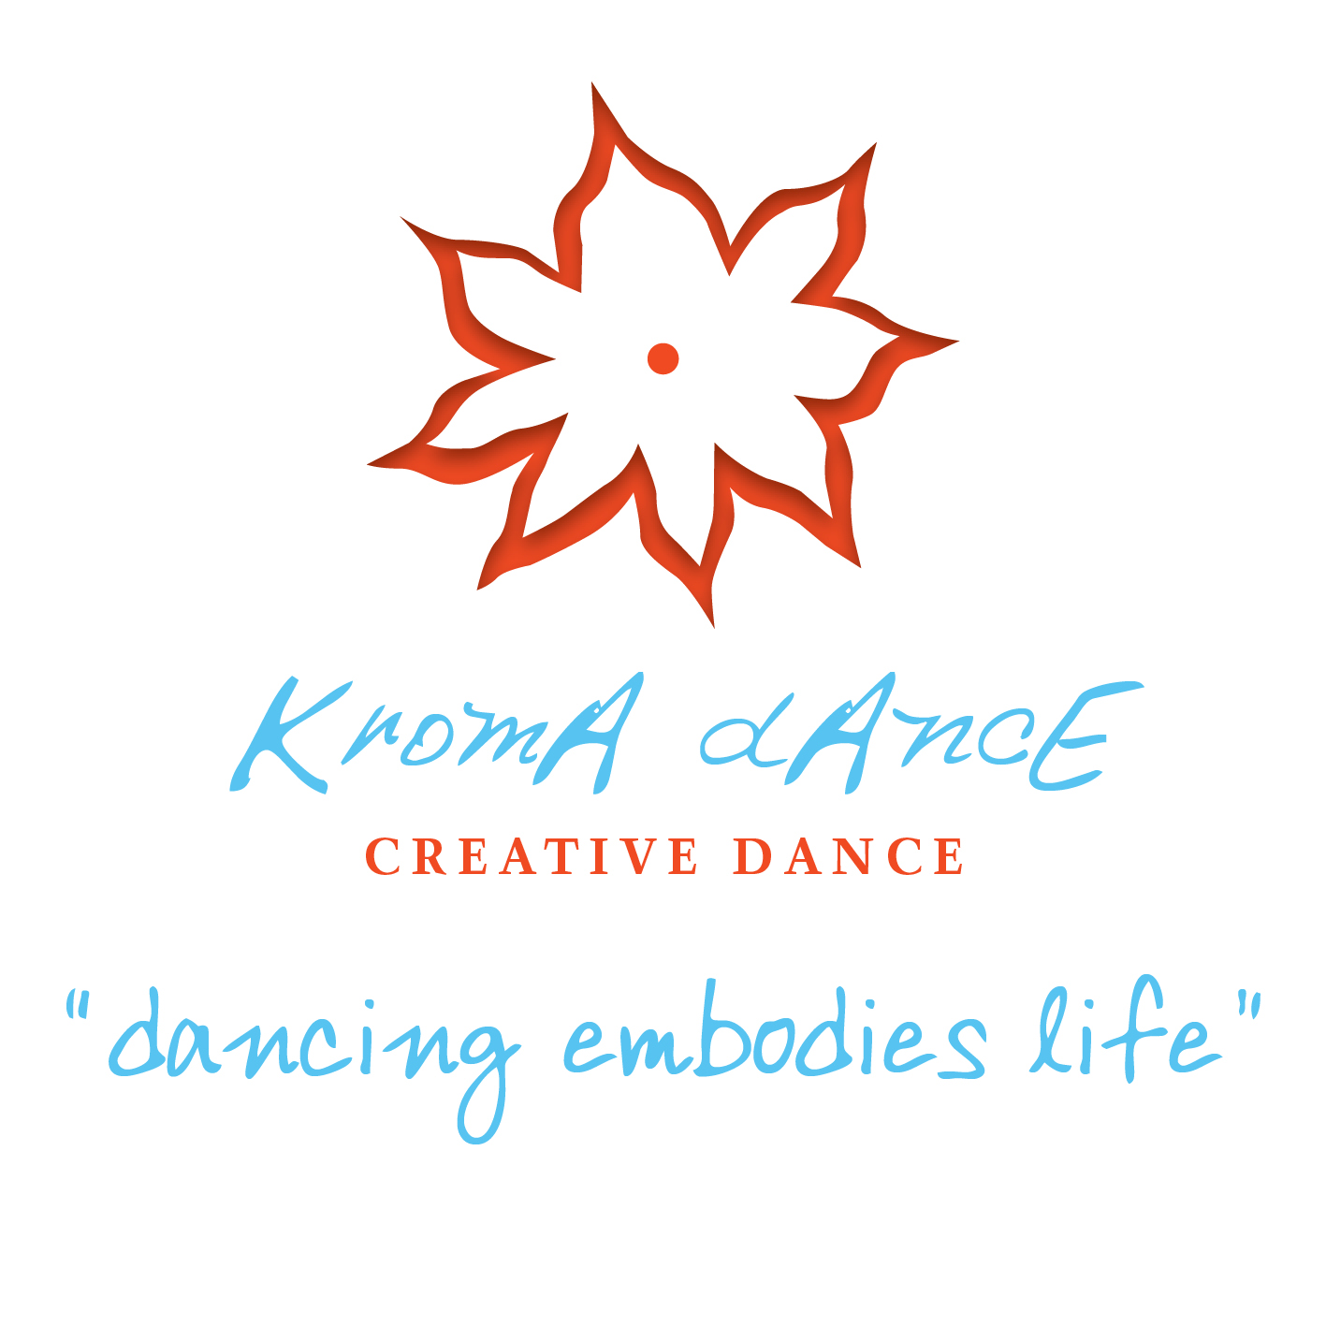
TERM 2, 2019
Croxton Park Uniting Church, 326 St Georges Rd., Thornbury

DANCER’S NAME: ……………………………………………………………AGE (incl DOB)……………………………….

PARENT/GUARDIAN NAME: ……………………………………………………………………………………………………

ADDRESS: ………………………………………………………………………………………………………………………......

…………………………………………………………………………………………………… POST CODE: ……………….....

PHONE NUMBERS: (M) ………………………………………….……. (M) ……………………………………………………..

EMAIL: ………………………………………………………………………………………………………………………………..

CLASS DAY ……………………..…… CLASS TIME …….…………………… AGE GROUP ………………………………….

2019 TERM 2: SATURDAY 4th MAY – SATURDAY 29th JUNE, 2019
Grades 3,4 & 5………….10.30am – 11.45am
Years 8 +………………..12.15pm – 1.30pm

FEES - $198 for 9 week term to be paid by Saturday 18TH May
(fees paid after due date will incur a $10 administration charge)
If there are any issues with fees please let me know

INTERNET BANK TRANSFER
ACCOUNT NAME: KROMA DANCE BSB: 063114 ACCOUNT NUMBER: 1042 6221

- DANCERS SHOULD WEAR COMFORTABLE CLOTHING (no jeans please and everyone
dances barefoot)
- PLEASE BE PUNCTUAL SO WE MAY START THE CLASS TOGETHER
- IMAGES (MOVING OR STILL) MAY BE TAKEN DURING THE CLASS AND USED FOR PROMOTIONAL PURPOSES – please let me know if you do not want this

If you have any enquiries please contact me anytime.
Kathy Vlassopoulos - Nina
ph: 9387 4774 mob: 0409 355 602
kroma_blue@yahoo.com.au
www.creativedanceforchildren.com.au
Facebook: www.facebook.com/kromadance

